**TCP EXPLORATION SOLUTION**

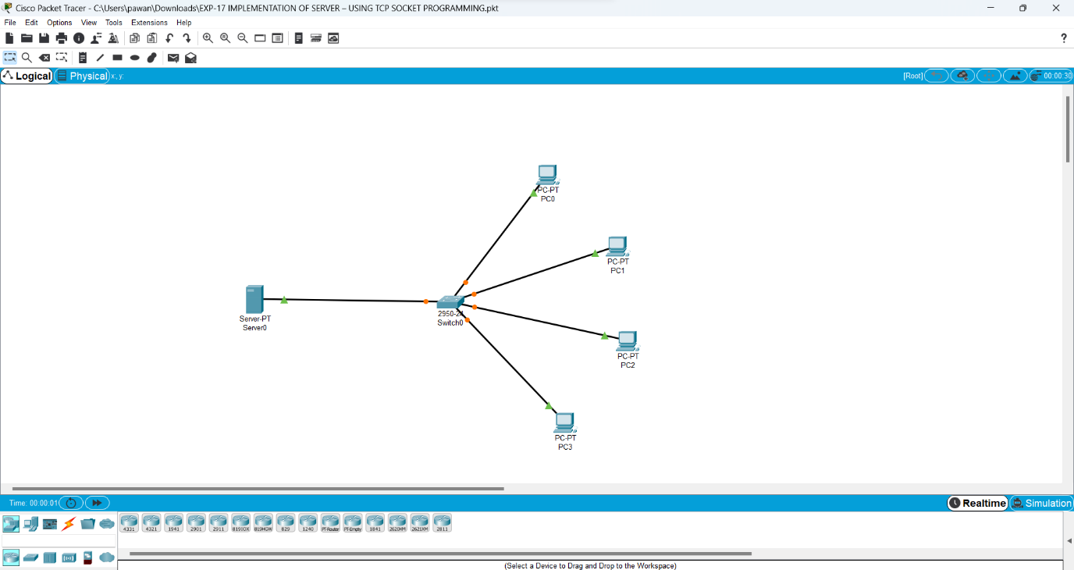

**UDP EXPLORATION SOLUTION**

